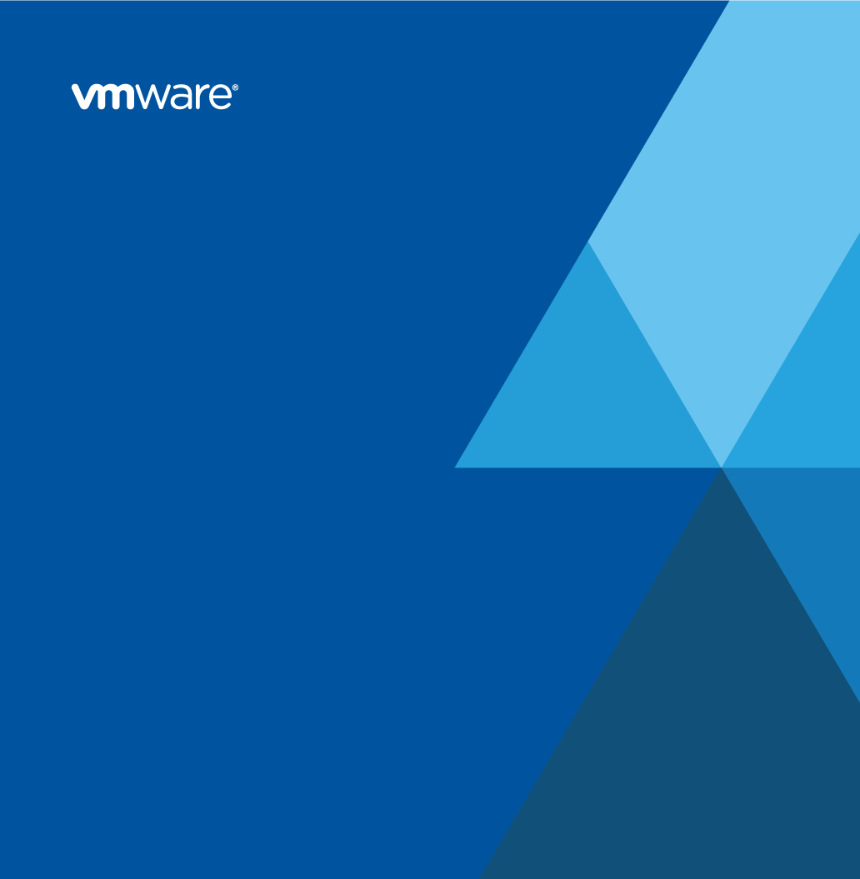

**VMware Integration and Extensibility Operations Guide**

for



Prepared by

Scott Wolfram

VMware Professional Services

swolfram@vmware.com

Version History

|  |  |  |  |  |
| --- | --- | --- | --- | --- |
| Date | Ver. | Author | Description | Reviewers |
| 1/21/2021 | .1 | Scott Wolfram | Initial Population |  |
|  |  |  |  |  |

© 2020 VMware, Inc. All rights reserved. This product is protected by U.S. and international copyright and intellectual property laws. This product is covered by one or more patents listed at <http://www.vmware.com/download/patents.html>.

VMware is a registered trademark or trademark of VMware, Inc. in the United States and/or other jurisdictions. All other marks and names mentioned herein are the trademarks of their respective companies.

VMware, Inc.  
3401 Hillview Ave  
Palo Alto, CA 94304  
[www.vmware.com](http://www.vmware.com)

# Contents

Version History 2

Contents 3

1. About This Document 4

2. Extension Overview 5

2.1 Extensions in vRealize Automation Service Broker 5

2.2 Extensions in vRealize Orchestrator 7

3. Configuration 8

3.1 Configure the Extensions in vRealize Service Broker 8

3.2 Configure the Extensions in vRealize Orchestrator 11

3.3 Configure the POD Configuration Repository 13

3.4 Configure the vRealize LifeCycle Password Lockers 20

4. Troubleshooting 22

4.1 Accessing the vRealize Automation Log Files 22

# About This Document

This Operations Guide provides instructions on configuring and using the functionality provided by the solution *Wells Fargo WAVE VCF Compliance Automation*.

The information in this guide is intended for experienced system administrators who are familiar with datacenter operations in VMware vSphere®, VMware vRealize™ Automation, and VMware vRealize™ Orchestrator™.

This document is provided in confidence and must not be shared with any third party without an explicit permission by VMware.

# Extension Overview

This section contains information about the components that are installed with the Wells Fargo WAVE VCF Compliance Automation solution.

## Extensions in vRealize Automation Service Broker

The following blueprints appear on the

* **Test**: <https://vtsl1-vra.wellsfargo.net/catalog>

Table 1. Extensions Installed in vRealize Automation Service Broker

|  |  |
| --- | --- |
| Blueprint | Description |
| PodAutomation | Main UI entry point into automating configuration within a specific POD. |

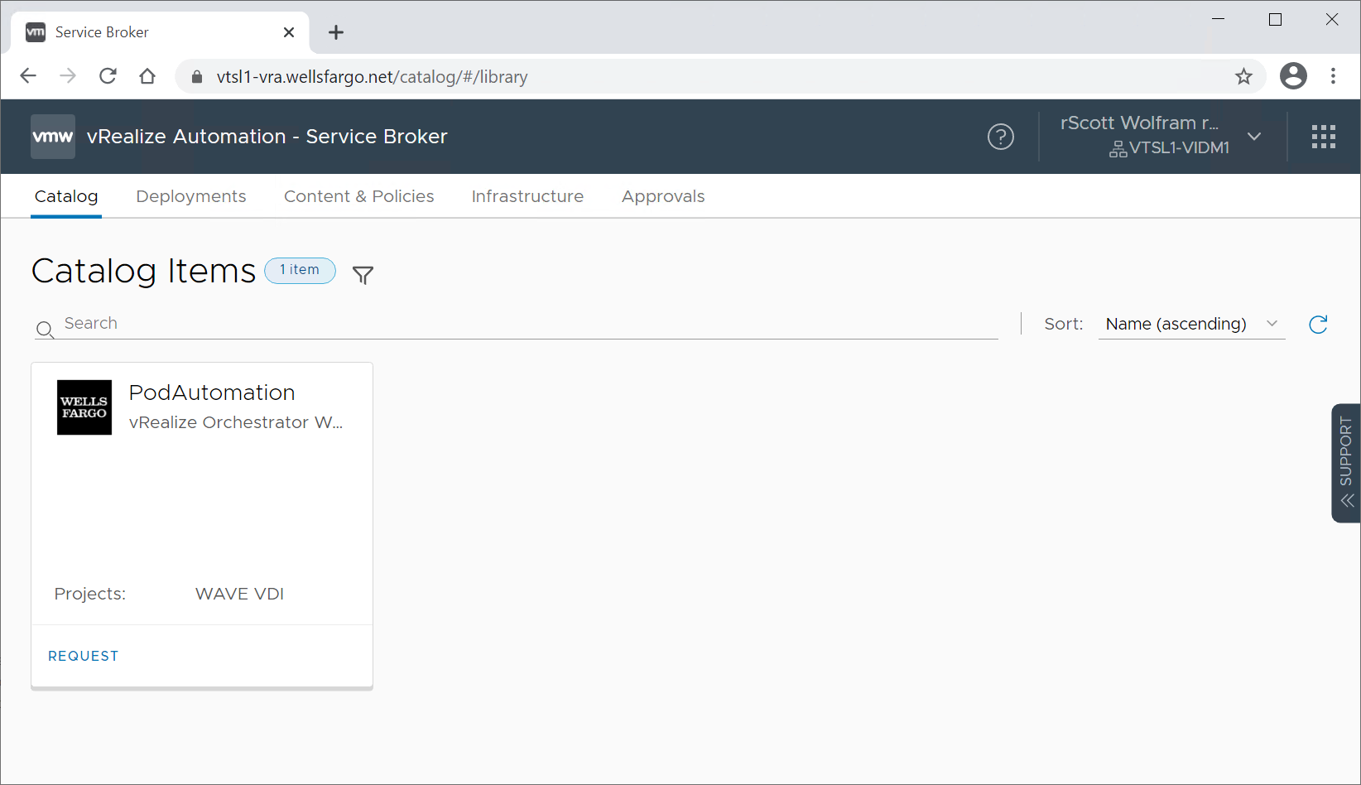

The integration can be executed by selecting the “Request” item link, then selecting the “Environment” -> “Region” -> “POD ID” to configure. The “Enable Override” is only to be used by developers for fast troubleshooting.

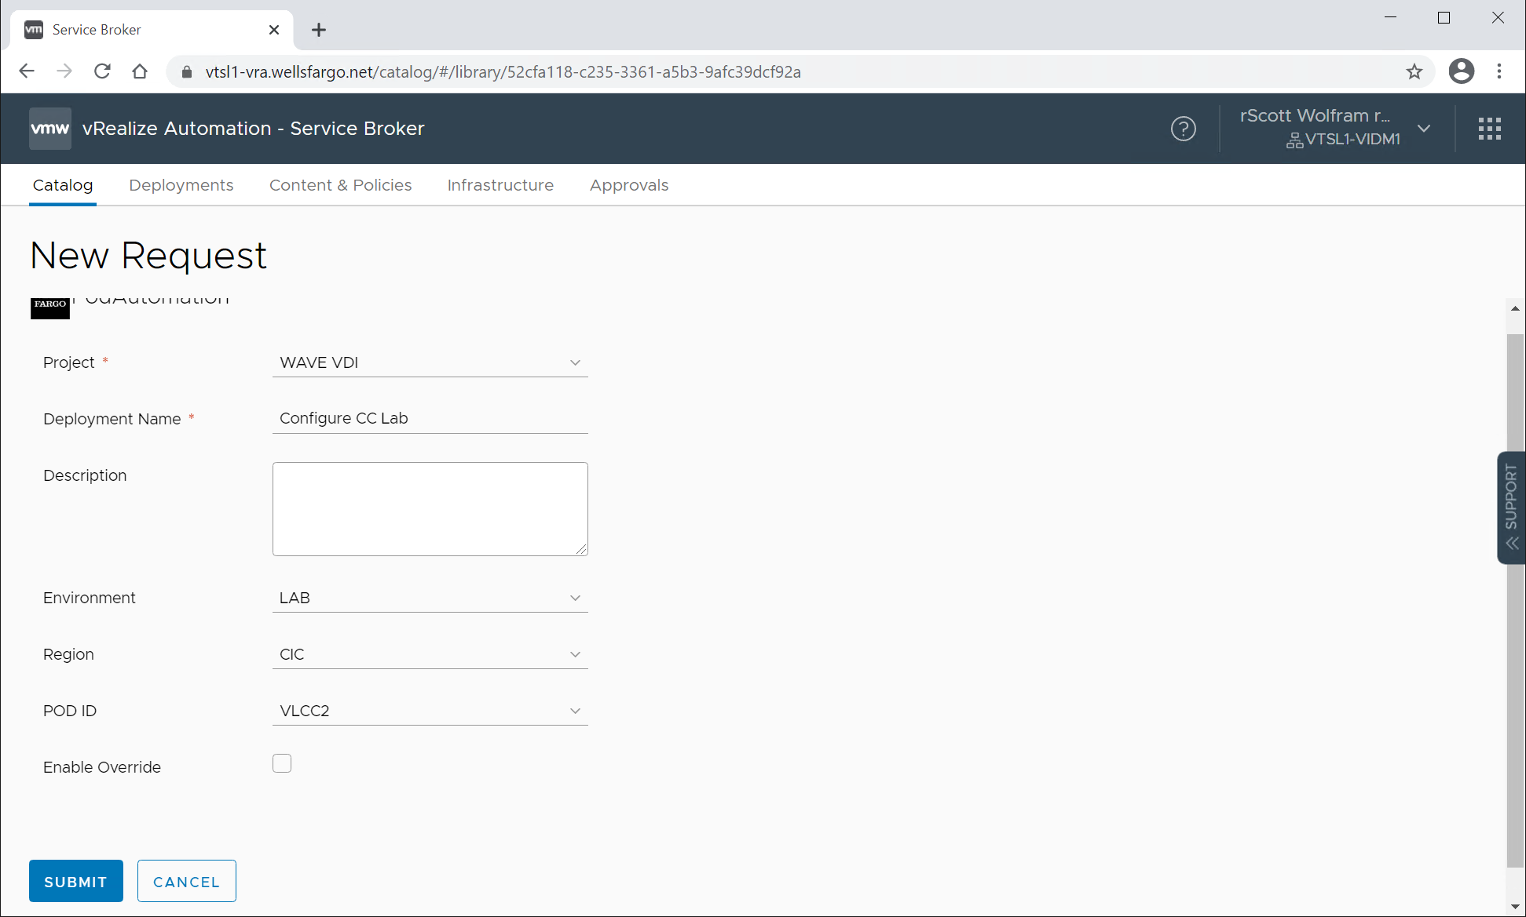

## Extensions in vRealize Orchestrator

The following workflows appear in the Workflows view.

Table 2. Extensions Installed in vRealize Orchestrator

|  |  |
| --- | --- |
| Workflow | Description |
| PSO\Pod\PodAutomation | Main workflow to drive the various integrations to configure a POD. |

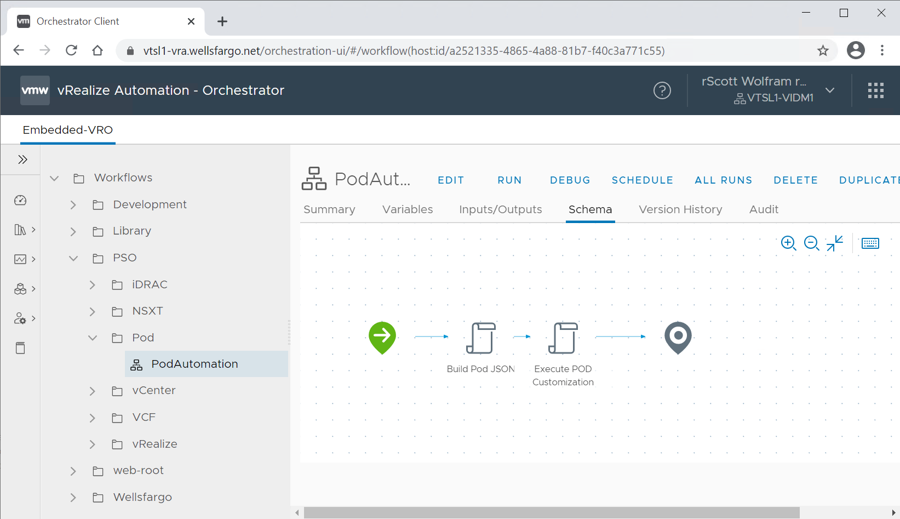

# Configuration

The solution is made up of four components, vRealize Service Broker, vRealize Orchestrator, vRealize Lifecycle Manager, and GitHub Enterprise. The next few sections will describe the configurations available in each.

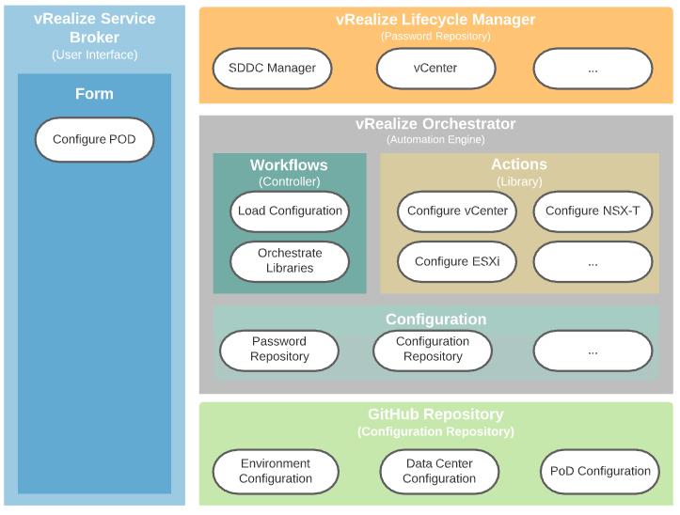

## Configure the Extensions in vRealize Service Broker

The Service Broker form only has one configuration option which is a pointer into the configuration in vRO. This configuration is used to define where the drop-down fields are populated from.

Prerequisites

* Verify that the component is installed properly. See installation guide for help.
* Log in to the vRealize Automation portal as an administrator.

Procedure

1. After logging into vRealize Automation portal select the “Service Broker Service”

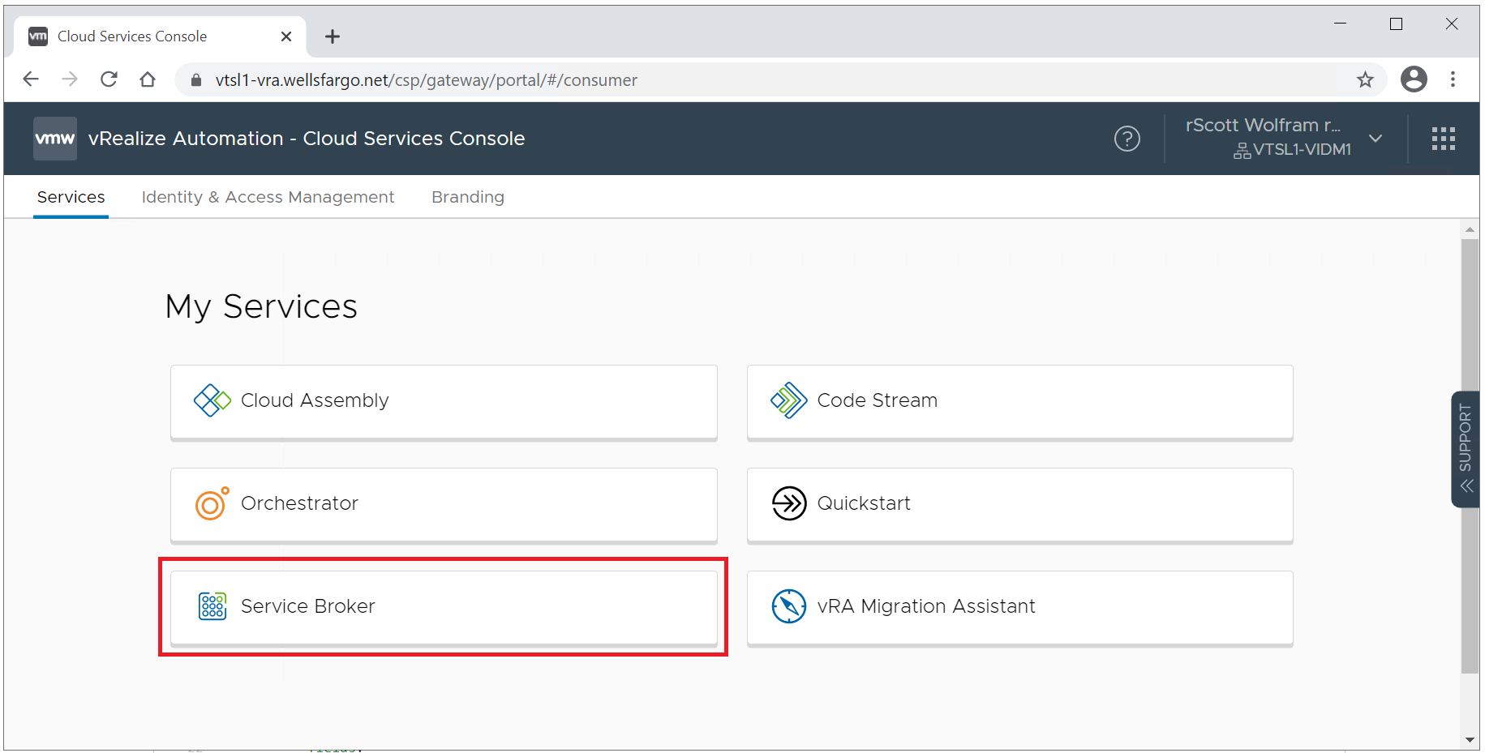

1. Select the “Content & Policies” tab near the top, then the “Content” subsection, using the vertical “...” next to the “PodAutomation” form and select “Customize form”.

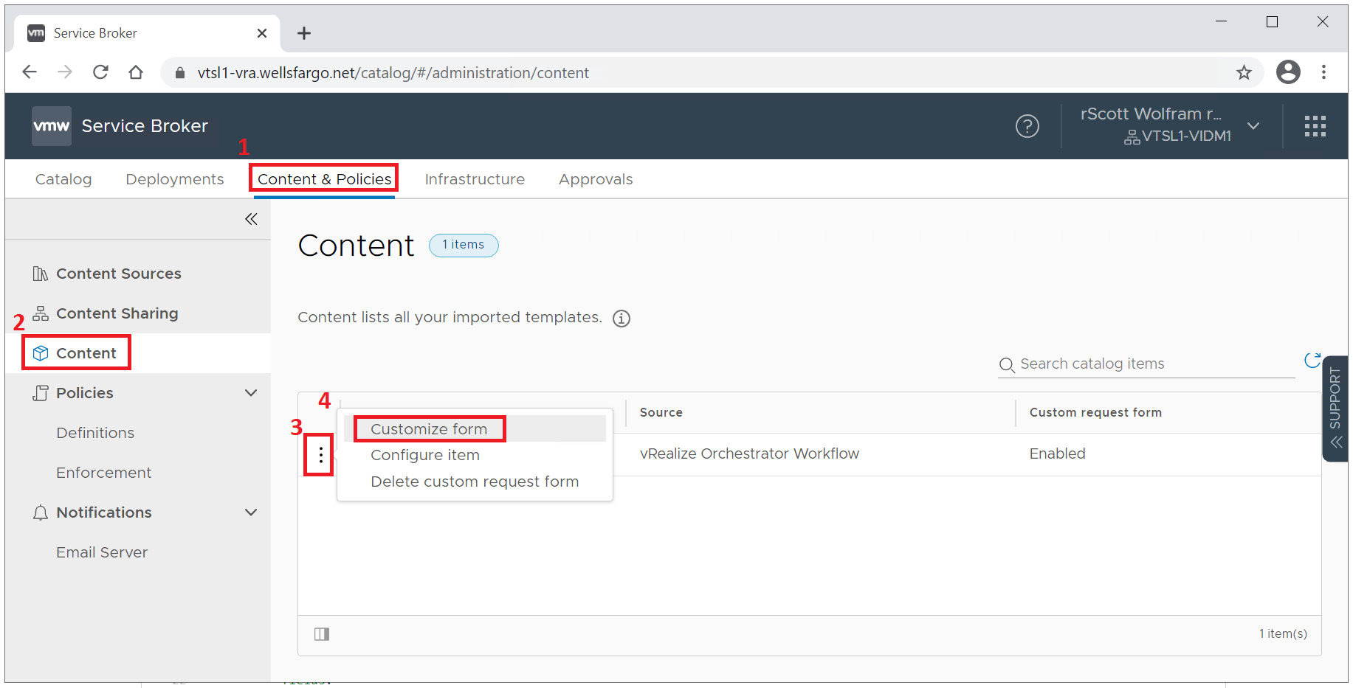

3. Select the “ConfigPath”, then “Values” and modify the Default value. This is the vRO configuration objects folder to use for the Git repository. The 2nd picture shows the folder in vRO this points to for better clarity.

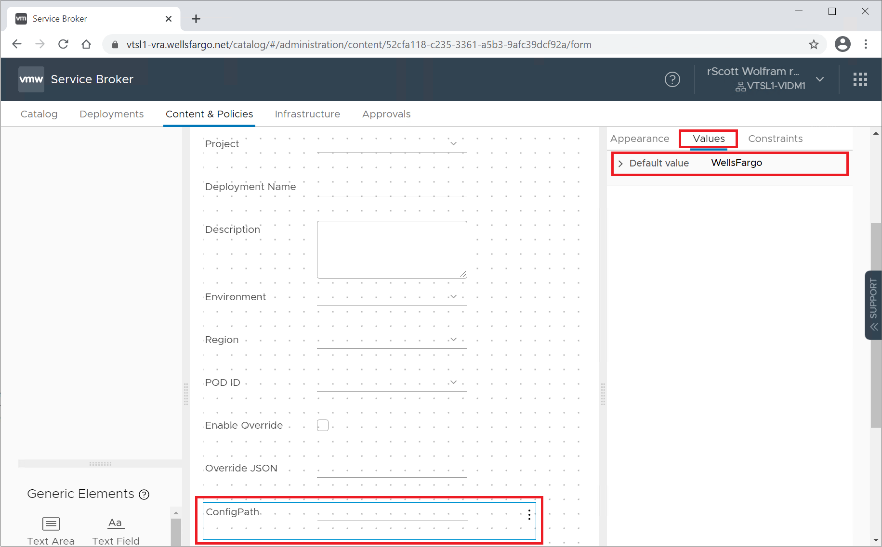

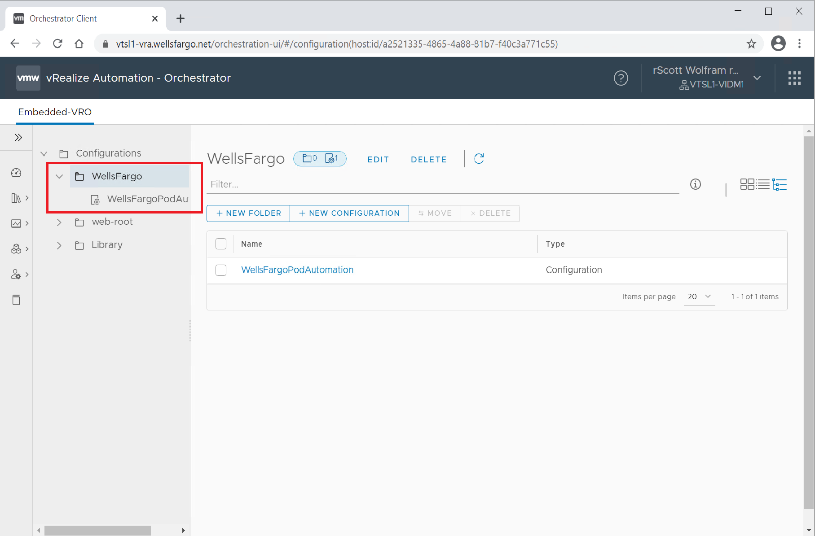

## Configure the Extensions in vRealize Orchestrator

Prerequisites

* Verify that the component is installed properly. See installation guide for help.
* Log in to the vRealize Orchestrator appliance as an administrator user.

Procedure

1. From the “Assets” menu on the left-hand side select the “Configuration”. Navigate to the “Configurations\WellsFargo\WellsFargoPodAutomation” configuration element. Select the “Edit” option near the top.

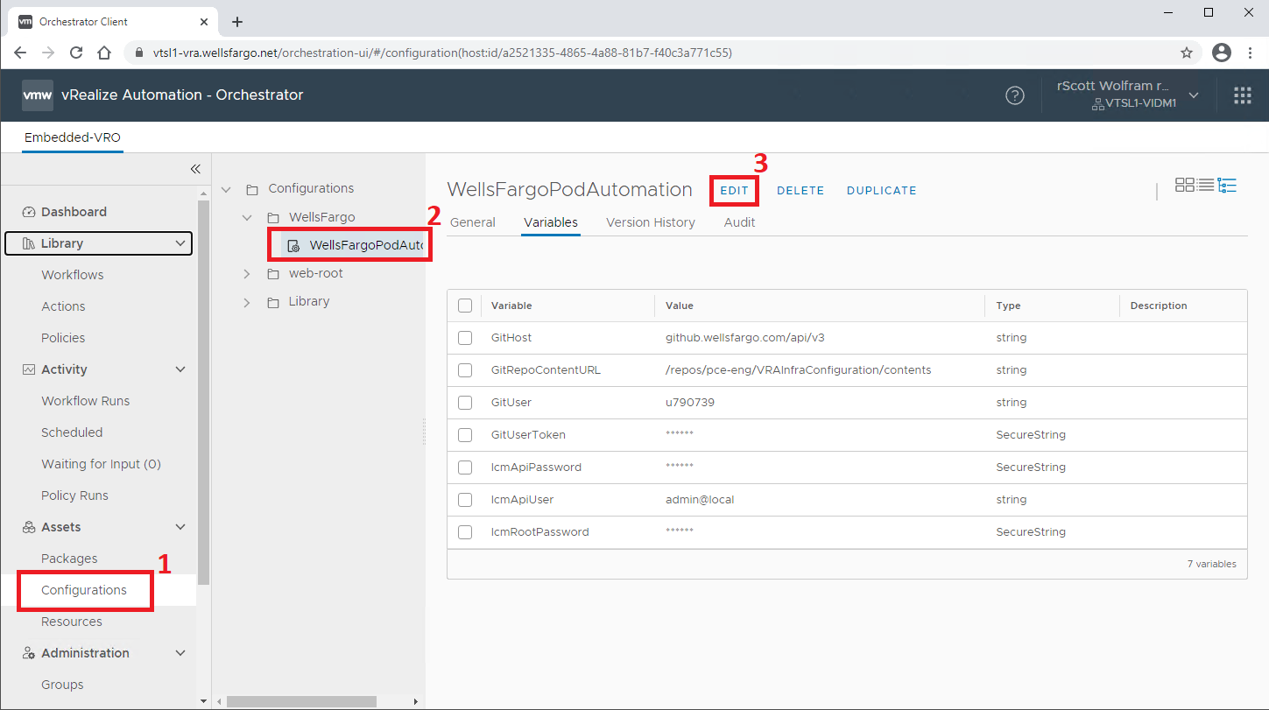

1. Select the “Variables” tab to show the variables stored in the configuration item.

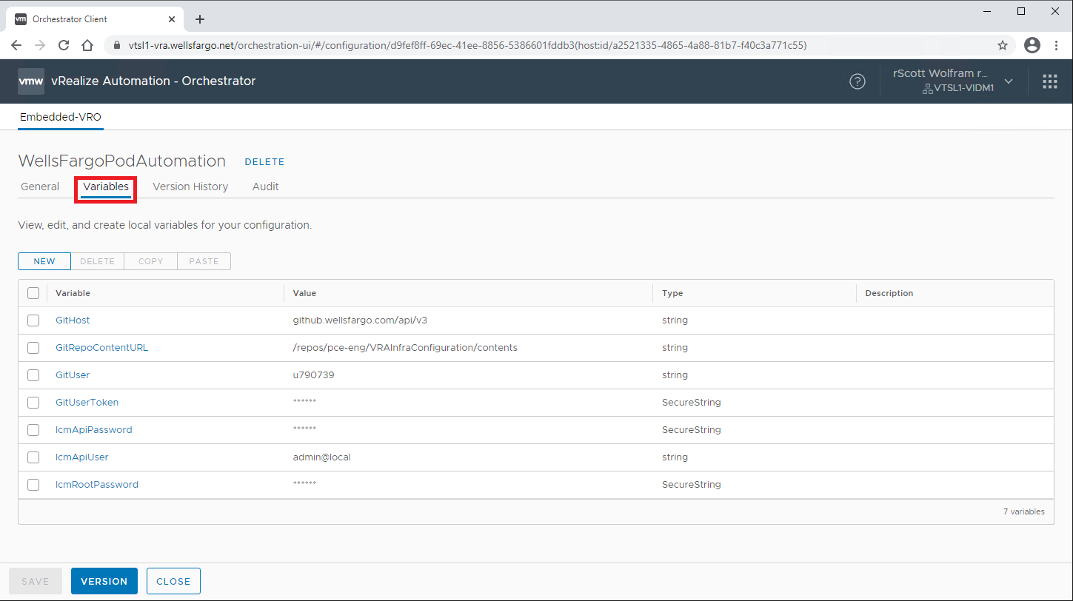

1. Using the guide below select the variable you want to edit and only edit the “Value” field.

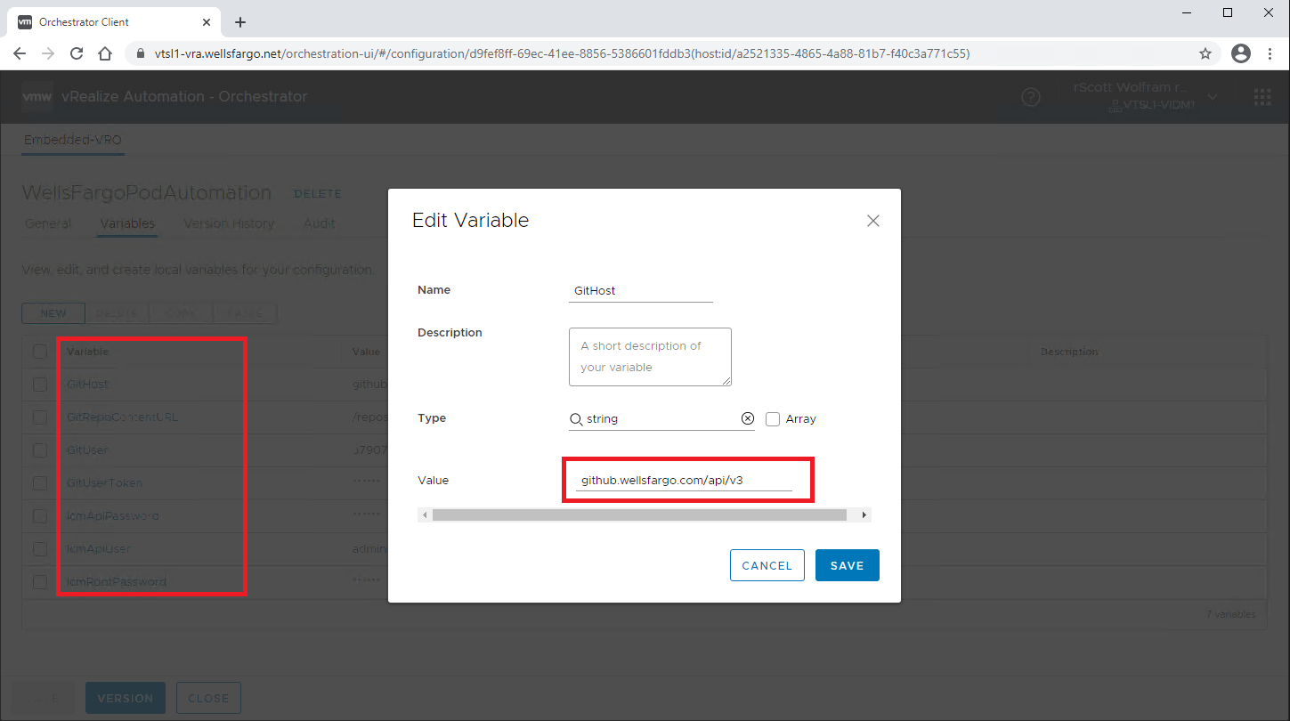

|  |  |
| --- | --- |
| Name | Description |
| GitHost | The FQDN of the git host where the POD configuration is stored |
| GitRepoContentURL | The path to the git repository where the POD configuration is stored |
| GitUser | The username to access the POD configuration git repository |
| GitUserToken | The API token that matches the username to access the POD configuration git repository |
| lcmApiPassword | The password to access the LCM server’s API |
| lcmApiUser | The username to access the LCM server’s API |
| lcmRootPassword | The root password to the LCM server, used to decrypted passwords stored in the locker |

## Configure the POD Configuration Repository

Prerequisites

* Verify that the component is installed properly. See installation guide for help.
* Log in to the Git configuration repository portal as an administrator, typically <https://github.wellsfargo.com/pce-eng/VRAInfraConfiguration>

Procedure

1. Select the Globals.json file to edit it.

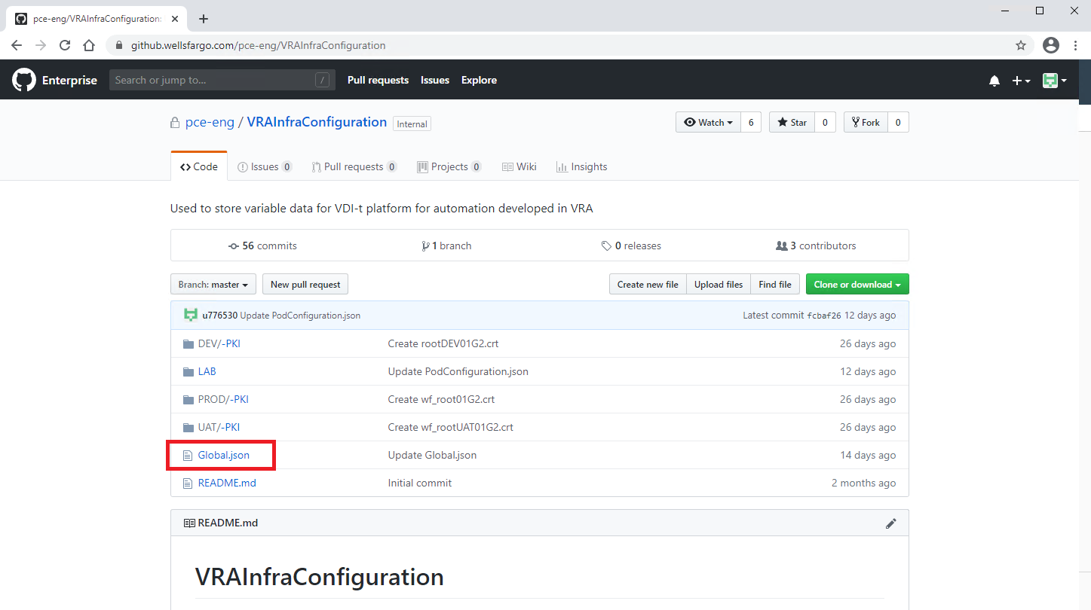

1. Select the edit icon (pencil).

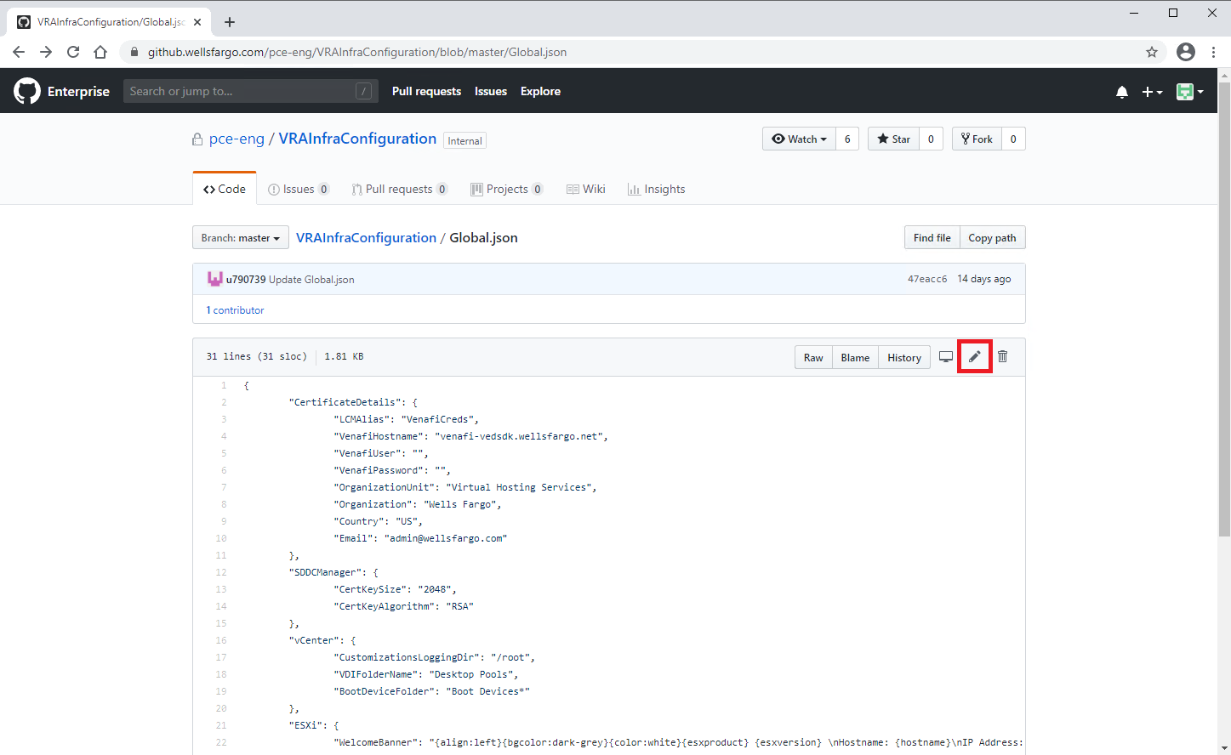

1. Edit the json for global parameters, example below.

{

"CertificateDetails": {

"LCMAlias": "VenafiCreds",

"VenafiHostname": "venafi-vedsdk.wellsfargo.net",

"VenafiUser": "",

"VenafiPassword": "",

"OrganizationUnit": "Virtual Hosting Services",

"Organization": "Wells Fargo",

"Country": "US",

"Email": "admin@wellsfargo.com"

},

"SDDCManager": {

"CertKeySize": "2048",

"CertKeyAlgorithm": "RSA"

},

"vCenter": {

"CustomizationsLoggingDir": "/root",

"VDIFolderName": "Desktop Pools",

"BootDeviceFolder": "Boot Devices*"

},

"ESXi": {

"WelcomeBanner": "{align:left}{bgcolor:dark-grey}{color:white}{esxproduct} {esxversion} \nHostname: {hostname}\nIP Address: {ip} \nSerial Number: {serial-number}\nService Tag: {servicetag}{bgcolor:yellow}{color:black}\n \n \n******************** WARNING: For Authorized Use Only ********************\n*You have accessed a private computer system. Unauthorized access, use, *\n*connection, or entry is not permitted and constitutes a crime punishable*\n*by law. We reserve the right to fully pursue criminal and civil legal *\n*penalties. All individuals using this computer system with or without *\n*proper authority are subject to having all their activities monitored *\n*and recorded. Anyone using this system implicitly consents to this *\n*monitoring. Any evidence of suspected criminal activity revealed by *\n*such monitoring may be provided to law enforcement officials. *\n**************************************************************************\n \n{/color}{/bgcolor}{/align}",

"DumpvNIC": "vmk2",

"ShellTimeout": "0",

"ShellInteractiveTimeout": "900"

},

"NSXT": {

"EnableIPv6": true,

"ipDiscoveryProfileName": "vdi-guest-ip-discovery-profile"

}

}

1. Near the bottom enter a title and description, then select “Commit changes”

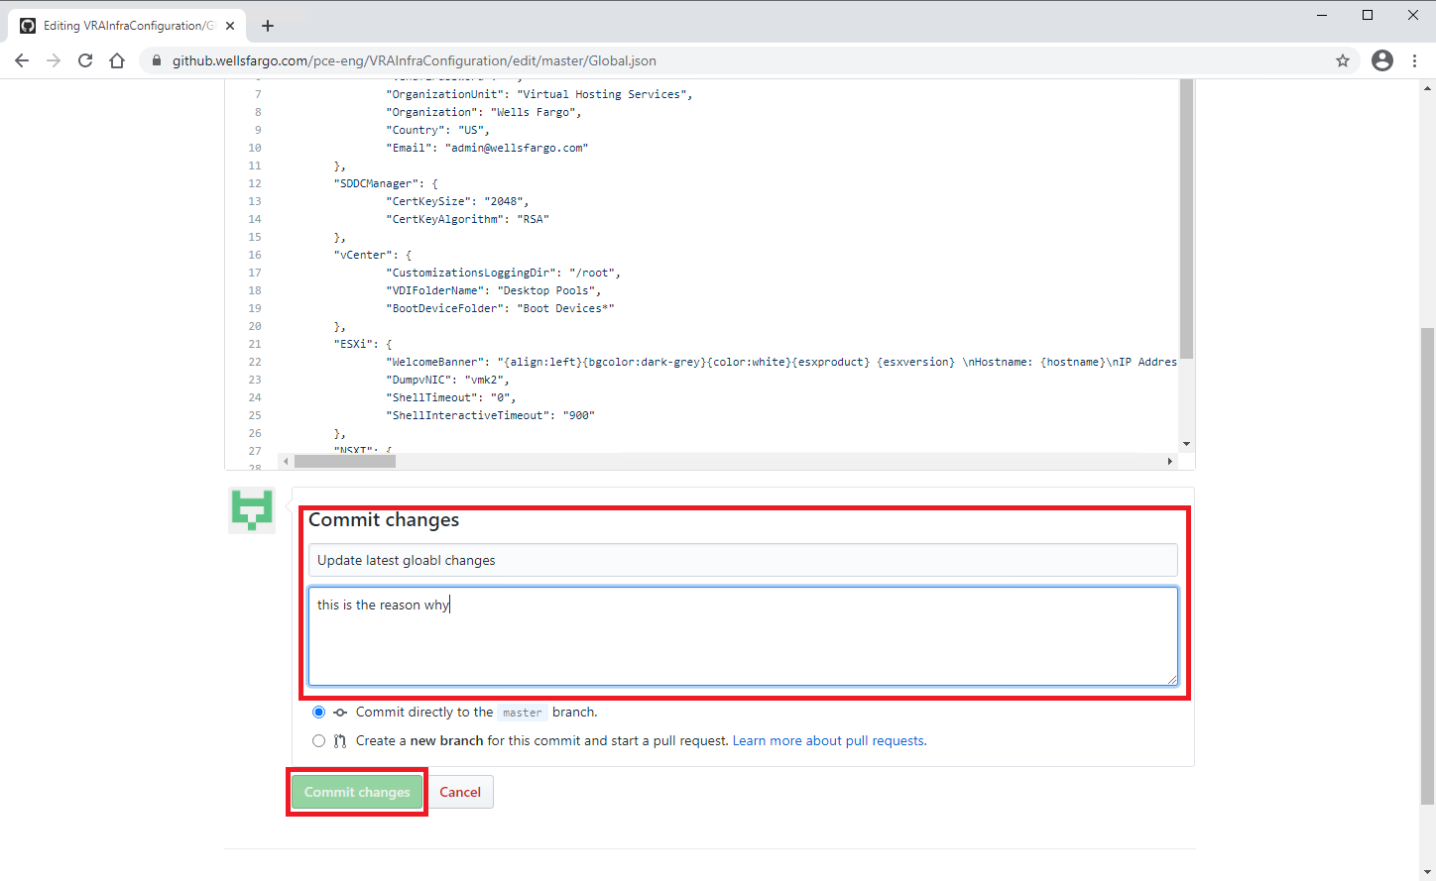

1. Navigate into the environment/region folder and edit the RegionDetail.json

{

"CertificateDetails": {

"RootCertificate": "LAB/-PKI/rootDEV01G2.crt",

"City": "San Francisco",

"State": "CA",

"Locality": "San Francisco"

},

"ActiveDirectory": {

"LCMAlias": "ActiveDirectoryCreds",

"DomainFQDN": "ent.wfb.bank.qa",

"DomainBaseDN": "DC=ent,DC=wfb,DC=bank,DC=qa",

"ADJoinUser": "",

"ADJoinPassword": "",

"ADOrgUnit": "OU=LAB VDI-T,OU=Lab POC Objects,OU=Lab Testing,OU=Virtual Engineering,OU=Delegated OUs,OU=EHS,OU=ENT,DC=ent,DC=wfb,DC=bank,DC=qa"

},

"vRLCM": {

"Hostname": "vtsl1-vlcm1.wellsfargo.net"

},

"WebProxy": {

"Hostname": "proxy.wellsfargo.com",

"Port": "8080",

"User": "",

"Password": ""

},

"SDDCManager": {

"LCMBackupAlias": "SDDCManagerBackupCreds",

"LCMSSOAdminAlias": "DefaultSDDCManagerSSOCreds",

"LCMLocalUserAlias": "DefaultSDDCManagerRootCreds",

"BackupHostname": "10.0.0.152",

"BackupHostPort": "22",

"BackupHostUsername": "",

"BackupHostPassword": "",

"BackupHostDirectoryPath": "/tmp",

"BackupHostSSHFingerPrint": "SHA256:6DaNMbiKRBdvm5rNsORtRzWuODKYr/hT/V0g4kM67Gw",

"RootCertKeystoreAlias": "rootcert"

},

"vCenter": {

"KMS": {

"LCMAlias": "KmsPassword",

"ProviderName": "SafeNet",

"KmsPassword": "",

"KmsServers": [

{

"FriendlyName": "snetks-dev-cic01",

"Hostname": "snetks-dev-cic01.wellsfargo.com",

"Port": "5697"

},

{

"FriendlyName": "snetks-dev-cic02",

"Hostname": "snetks-dev-cic02.wellsfargo.com",

"Port": "5697"

},

{

"FriendlyName": "snetks-dev-azte01",

"Hostname": "snetks-dev-azte01.wellsfargo.com",

"Port": "5697"

},

{

"FriendlyName": "snetks-dev-azte02",

"Hostname": "snetks-dev-azte02.wellsfargo.com",

"Port": "5697"

}

]

},

"CustomStoragePolicyDiskStripes": "5",

"CustomStoragePolicyFTT": "2",

"SyslogPort": "1514",

"SyslogProtocol": "TLS",

"noProxyHosts": [],

"NFSDatastoreName": "NFS01",

"NFSHostnameIP": "10.0.0.10",

"NFSSharePath": "/netshare",

"Access": {

"vRealizeRoles": {

"LCMADGroupsUsers": ["QA-ENT\\PRV_TIS_SA_SRV_ENGSUPPORT"],

"vRLIADGroupsUsers": ["QA-ENT\\PRV_TIS_SA_SRV_ENGSUPPORT"],

"vROPSADGroupsUsers": ["QA-ENT\\PRV_TIS_SA_SRV_ENGSUPPORT"],

"vRAADGroupsUsers": ["QA-ENT\\PRV_TIS_SA_SRV_ENGSUPPORT"]

},

"HorizonRoles": {

"Appliance_Deployment": {

"RoleName": "VM Appliance Deployment",

"ADGroups": ["QA-ENT\\PRV_CPS_SA_SRV_OSSDServerAdmin"]

},

"Hzn_vC_Admin": {

"RoleName": "Horizon vCenter Admin",

"ADGroups": [

"QA-ENT\\PRV_EFO_SA_SRV_HZ_ADMIN"

]

},

"Hzn_vC_Infra_Admin": {

"RoleName": "Horizon vCenter Infra Admin",

"ADGroups": [

"QA-ENT\\PRV_EFO_SA_SRV_HZ_ADMIN",

"QA-ENT\\PRV_EFO_SA_SRV_WAVEP_ADMIN"

]

},

"Hzn_Img_Mgmt": {

"RoleName": "Horizon Image Management",

"ADGroups": ["QA-ENT\\DTCS_EFO_HZ_DEV_ImageManagers"]

},

"App_Vol_vC_Admin_DisabledWaitingonGroup": {

"RoleName": "App Volumes vCenter Admin",

"ADGroups": ["QA-ENT\\euceng_vc_av_dev"]

},

"App_Vol_Pckg_Mgmt": {

"RoleName": "App Volumes Package Management",

"ADGroups": ["QA-ENT\\DTCS_EFO_HZ_VMPackager"]

},

"App_Vol_Dist_Mgmt": {

"RoleName": "App Volumes Distribution Management",

"ADGroups": ["QA-ENT\\DTCS_EFO_HZ_VMDistribution"]

},

"Content_Lib_Admin": {

"RoleName": "com.vmware.Content.Admin",

"ADGroups": ["QA-ENT\\DTCS_EFO_HZ_DEV_ContentLibRW"]

},

"No_Access": {

"RoleName": "NoAccess",

"ADGroups": [

"QA-ENT\\DTCS_EFO_HZ_DEV_ImageManagers",

"QA-ENT\\DTCS_EFO_HZ_VMPackager",

"QA-ENT\\DTCS_EFO_HZ_VMDistribution"

]

},

"Read_Only": {

"RoleName": "ReadOnly",

"ADGroups": ["QA-ENT\\DTCS_EFO_WAVE_VC_RO"]

},

"DTO_Lvl1_Vxrail": {

"RoleName": "DTO-Level1-Vxrail",

"ADGroups": [

"QA-ENT\\PRV_OPS_SA_SRV_DTO_ServerSupport_QA"

]

}

}

}

},

"vRLI": {

"LCMAlias": "vtsl1-vrli",

"Hostname": "vtsl1-vrli.wellsfargo.net",

"User": "",

"Password": ""

},

"vIDM": {

"LCMAlias": "vIDMClientId",

"Hostname": "vtsl1-vidm1.wellsfargo.net",

"AutomationClientID": "",

"AutomationClientSecret": ""

}

}

1. Navigate into the <environment>/<region>/PODS/<pod> folder and edit the PodConfiguration.json

{

"podID": "vlcc2",

"SDDCManager": {

"VMName": "",

"Hostname": "vlcc2-sddc.ntec.wellsfargo.net",

"LocalUser": "",

"LocalPassword": "",

"SSOAdminUser": "",

"SSOAdminPassword": "",

"EnableCeip": false,

"VenafiPolicyDN": "\\VED\\Policy\\EIT-Tech Infrastructure-VE (Ansible) - PKI Admins\\EIT-Tech Infrastructure-VE (Ansible)\\SSL WF Enterprise CA05 G2 (SHA-256) 1-year\\wave-vlcc2",

"Domains": []

},

"vCenter": {

"DumpPort": "6500",

"SolutionUserPolicyDN": "\\VED\\Policy\\EIT-Tech Infrastructure-VE (Ansible) - PKI Admins\\EIT-Tech Infrastructure-VE (Ansible)\\SSL WF Enterprise CA05 G2 (SHA-256) 1-year\\wave-vlcc2",

"mgmtvCenter": {

"VCFDomain": "",

"Hostname": "",

"VMName": "",

"IPAddress": "",

"SSOAdminUser": "",

"SSOAdminPassword": "",

"RootPassword": "",

"vdsName": "",

"vSanClusterName": [""]

},

"wldvCenters": [

{

"VCFDomain": "",

"Hostname": "",

"VMName": "",

"IPAddress": "",

"SSOAdminUser": "",

"SSOAdminPassword": "",

"RootPassword": "",

"vSanClusterNames": [""]

}

]

},

"ESXi": {

"esxiPolicyDN": "\\VED\\Policy\\EIT-Tech Infrastructure-VE (Ansible) - PKI Admins\\EIT-Tech Infrastructure-VE (Ansible)\\SSL WF Enterprise CA05 G2 (SHA-256) 1-year\\wave-vlcc2",

"Hosts": [

{

"Hostname": "",

"IPAddress": "",

"User": "",

"Password": ""

}

]

},

"NSXT": {

"UsingExternalLB": false,

"EnablevIDM": true,

"LDAPUsersOrGroups": [

{

"Name": "ru790739@ent.wfb.bank.qa",

"isGroup": "false",

"RoleName": "enterprise_admin"

},

{

"Name": "ru776530@ent.wfb.bank.qa",

"isGroup": "false",

"RoleName": "enterprise_admin"

}

],

"mgmtNSXT": {

"VCFDomain": "",

"ManagerVIP": "",

"ManagerHostnames": [],

"AdminUser": "",

"AdminPassword": "",

"RootPassword": ""

},

"wldNSXT": [

{

"VCFDomain": "",

"ManagerVIP": "",

"ManagerHostnames": [],

"AdminUser": "",

"AdminPassword": "",

"RootPassword": "",

"vdiSegments": [

{

"Name": "VDI Guest 01",

"VLAN": "1031"

},

{

"Name": "VDI Guest 02",

"VLAN": "1032"

},

{

"Name": "VDI Guest 03",

"VLAN": "1033"

},

{

"Name": "VDI Guest 04",

"VLAN": "1034"

},

{

"Name": "VDI Guest 05",

"VLAN": "1035"

}

]

}

]

},

"AutomationSwitches": {

"SDDCManager": {

"Opt out of CEIP": false,

"Trust Root Cert": false,

"Configure Proxy": false,

"Update Managed Certs": false,

"Configure Backup": false

},

"vCenter": {

"Update Solution User Certs": false,

"Configure Proxy": false,

"Set ESXi Cert Mode": false,

"Set Stats and Logging Level": false,

"Enable Dump Collector": false,

"Configure Hzn and vRZ Port Groups": false,

"Add NFS Storage": false,

"Create VDI Folder": false,

"Configure AD Settings": false,

"Create and Assign Roles": false

},

"ESXi": {

"Rotate Host Certs": false,

"Set Shell Timeout": false,

"Set Welcome Banner": false,

"Set Dump Collector": false

},

"vSAN": {

"Set Kms Provider": false,

"Enable vSan Encryption": false,

"Create Storage Policy": false

},

"NSXT": {

"Enable IPv6": false,

"Create VDI Segments": false,

"Configure Syslog": false,

"Configure AD Settings": false

}

}

}

## Configure the vRealize Lifecycle Manager Password Lockers

Prerequisites

* Verify that the component is installed properly. See installation guide for help.
* Log in to the LCM portal as an administrator.

Procedure

1. Select the “Locker” icon.

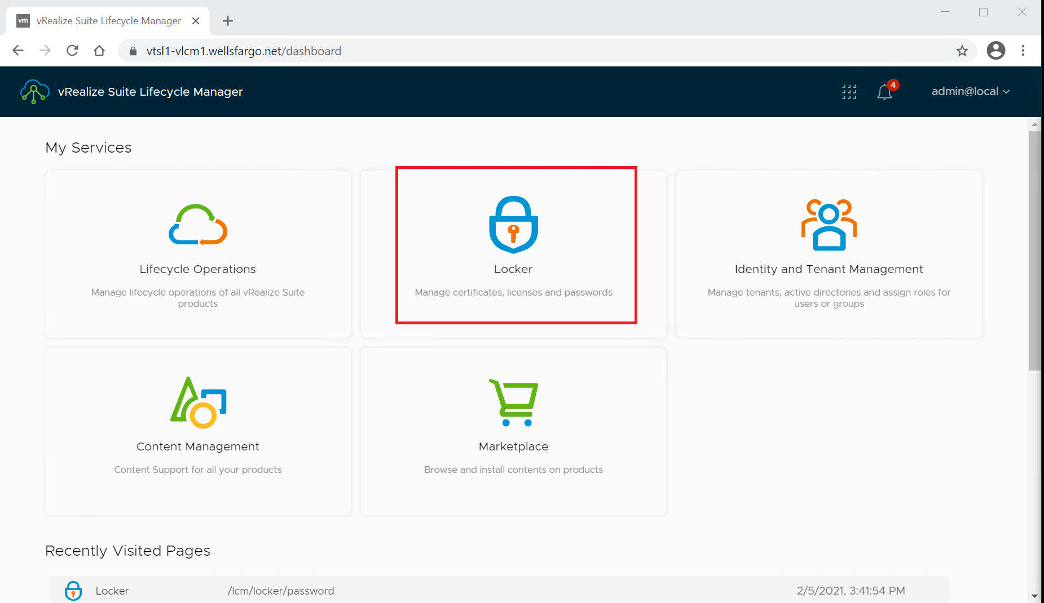

1. Select the “Passwords” section from the left-hand menu

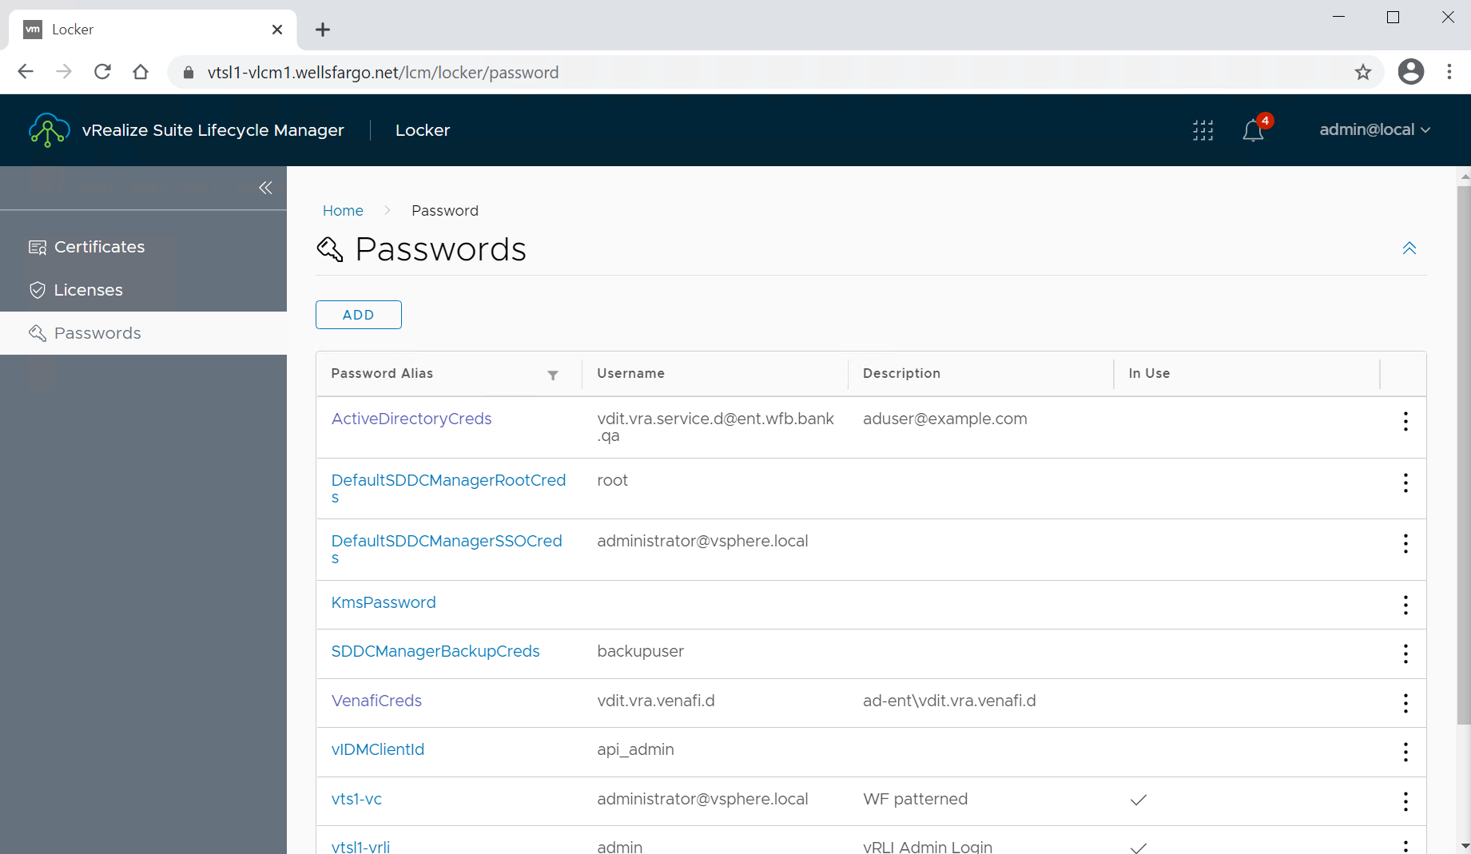

1. Use the vertical ellipse on the right-hand side of the target password and select “Edit Password”.

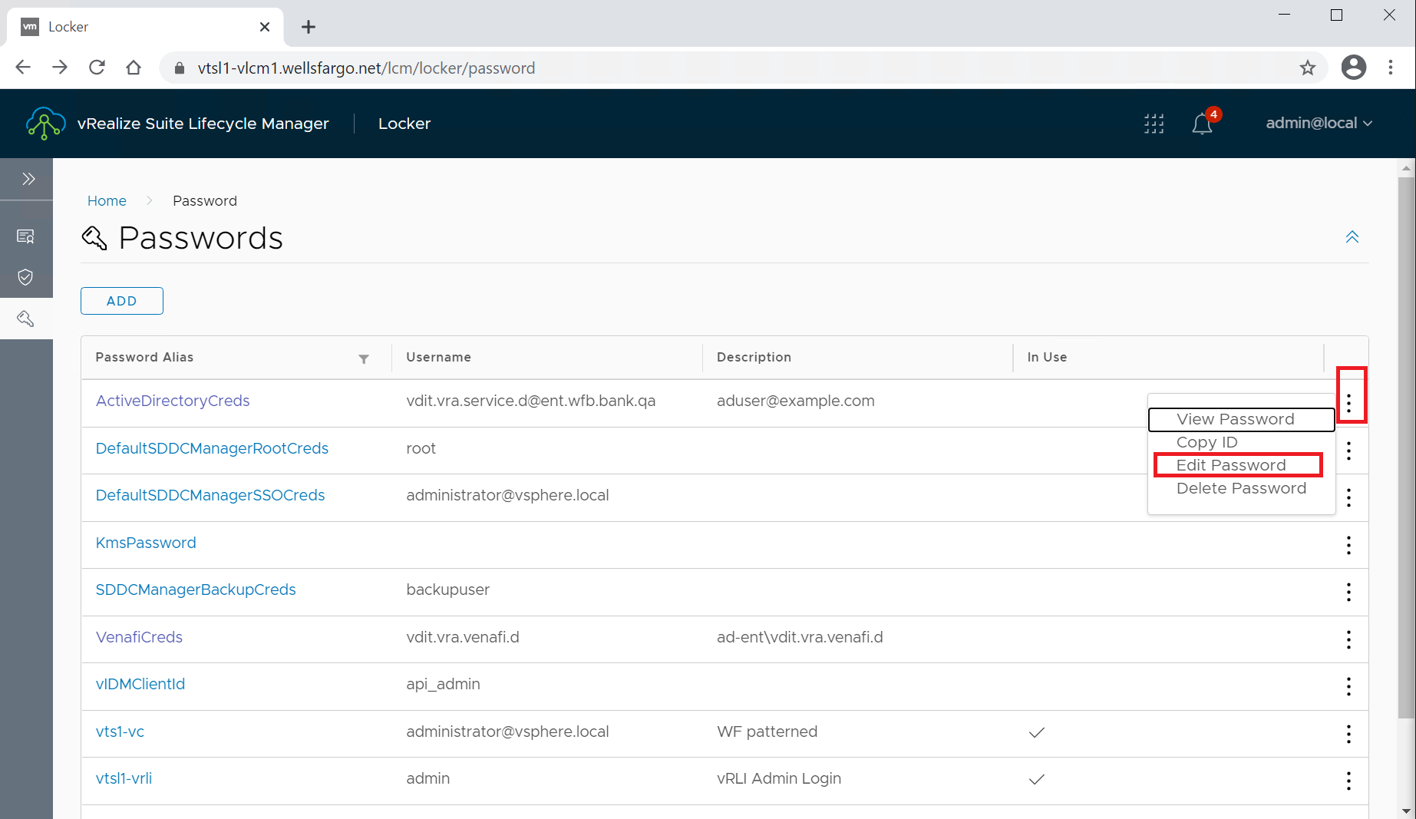

1. Enter and confirm the password, then select the “DONE” button.

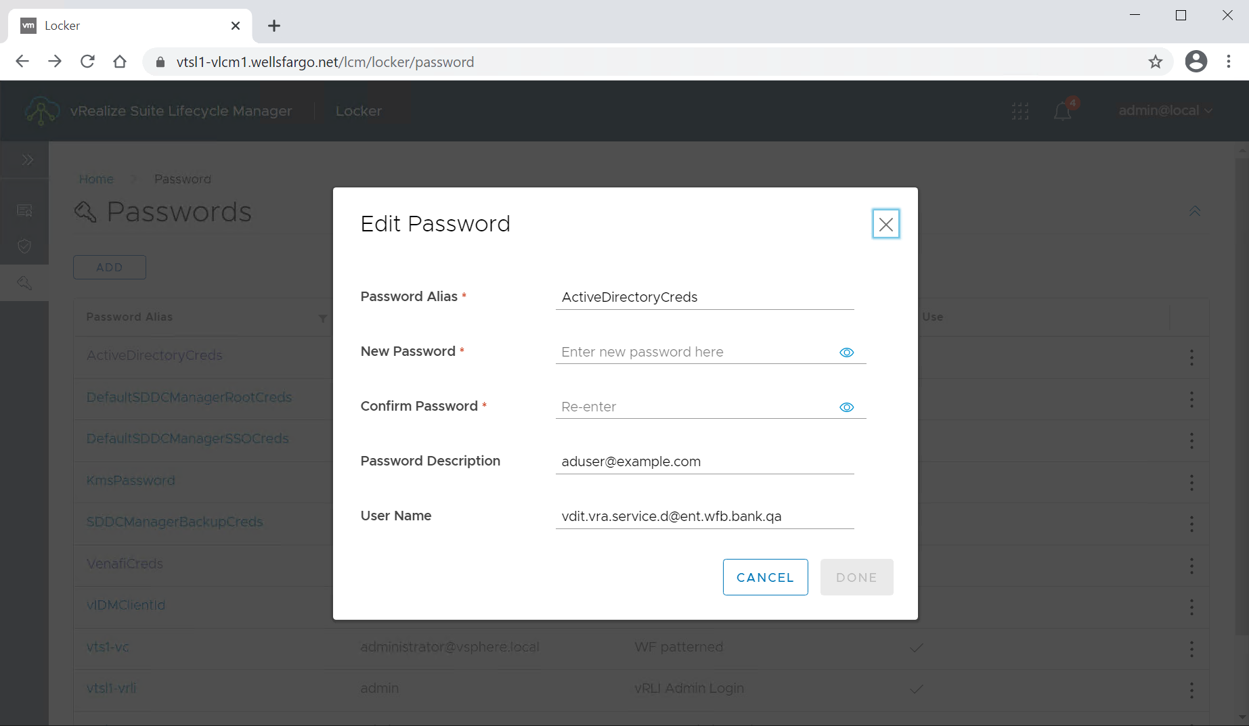

# Troubleshooting

You can review log files to monitor the solution and verify that no problems occur as it operates.

If a problem occurs, known troubleshooting information can help you diagnose and correct the problem.

## Accessing the vRealize Automation Log Files

1. Login to vRealize Orchestrator as an administrator, select “Workflow Runs” and then select the last run of “PodAutomation”.

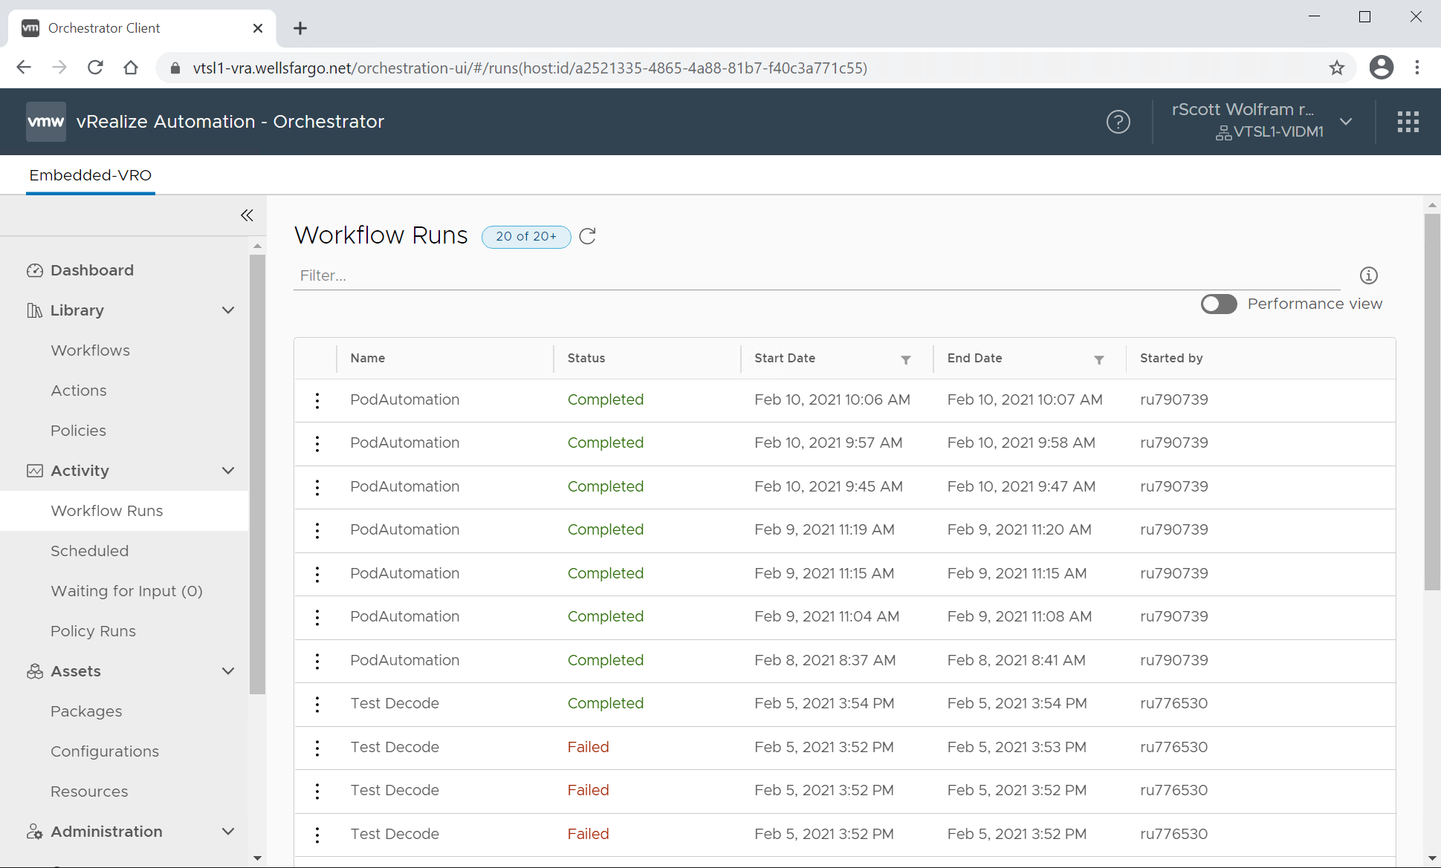

1. Select the “Logs” tab and review the logs, starting with red error messages for clues.

